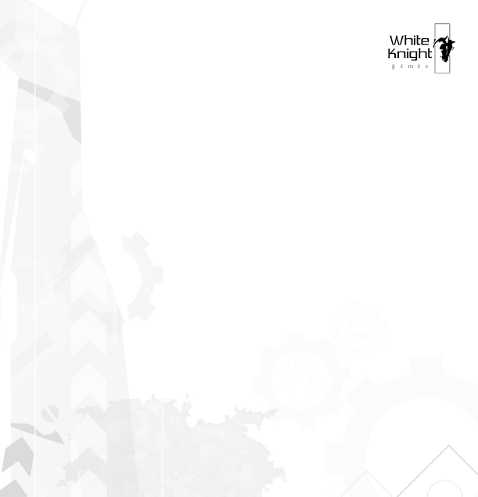
Mitchell Nunis
Marketing & Product Coordinator
White Knight Games
www.whiteknightgames.com
PO Box 62
South Perth, WA
Australia 6912
(+61) 403008003
mitchell@whiteknightgames.com

FOR IMMEDIATE RELEASE

White Knight Games to showcase Timothy & Titus at the 2005 Australian Game Developers Conference.

Perth, Western Australia – November 2005 - White Knight Games will be part of the official Western Australian contingent for this year’s Australian Game Developers Conference in Melbourne to showcase their highly anticipated debut title, ‘Timothy &: Saints, Martyrs, Heroes’ as part of their exposure to the Australian gaming industry.

The PC game, 'Timothy and Titus: Saints, Martyrs, Heroes' is the first effort of Australian niche computer games developer White Knight Games in the growing Christian computer game industry. Based on St Paul's disciples St Timothy and St Titus, the game follows their adventures in a fictional tale of fun, mystery, and adventure as they spread the Gospel message across the lands of early Christianity.

‘Timothy and Titus: Saints, Martyrs, Heroes’ marks the first of the 3D action adventure series envisioned by White Knight Games, targeted for children between the ages of 8 to 15 years.

‘Timothy and Titus: Saints, Martyrs, Heroes’ introduces the ‘Christian Gameplay Paradigm’ as a way of bringing to life core Christian virtues and actions to create a positive and enriching gaming experience. The title is set to be the first Australian Christian computer game title released.

Originally planned for a mid-November release, White Knight Games have announced recently on their website that fans will be able get their copy of ‘Timothy & Titus: Saints, Martyrs, Heroes’, from Easter 2006. Following extraordinary positive feedback from the Christian Game Developers Conference in July 2005, White Knight Games have sought to dramatically increase the quality and scope of the game.

“We’re delighted with the opportunity to show a glimpse of Timothy & Titus to the Australian gaming industry. We believe that there has been a lot of excitement lately around Christian gaming in general, and our game’s central theme of utilising non-violent solutions to obstacles has received a lot of praise” says Mitchell Nunis, Marketing and Product Coordinator of White Knight Games.

The Australian public will be able to experience first views and detailed information of the title, ‘Timothy & Titus: Saints, Martyrs, Heroes’ at the Australian Game Developers Conference held on the 1st –3rd November in Melbourne Australia. Currently available for pre-order from their website, the game will be released in Easter 2006.

For additional information on White Knight Games and ‘Timothy and Titus: Saints, Martyrs, Heroes', contact press@whiteknightgames.com or visit www.whiteknightgames.com.

About White Knight Games
Headquartered in Perth, Western Australia, computer games developer White Knight Games was formed in 2004 as a joint venture with Anino Entertainment. White Knight Games looks to revolutionize niche gaming with the goal of creating high-quality computer games for all ages.

As a non-negotiable company rule, White Knight Games aims to keep ‘Christ First in Christian Games’ true of their business activities too, pledging 10% of game profits to reduce poverty in the Philippines.

The technical team behind White Knight Games and 'Timothy and Titus: Saints, Martyrs, Heroes' is the award winning development house, Anino Entertainment. A finalist in the ‘2004 Independent Games Festival finalist’ for Anito – Defend a Land Enraged, Anino Entertainment went on to claim the award for the ‘Innovation in Audio’ category. Anino Entertainment’s design vision contributions, project management expertise, artistic talent and technical ingenuity are the driving force behind the high quality of Timothy & Titus and future White Knight Games projects.

###

